CSA1715-ARTIFICIAL INTELLIGENCE
LAB PROGRAMS
14-07-2026
3. Write the python program for Water Jug Problem.

Aim
To write a Python program to solve the Water Jug Problem using the Breadth-First Search (BFS) algorithm.

Algorithm
- Read the capacities of the two water jugs and the target amount from the user.
- Initialize a queue with the initial state (0,0) and store the path.
- Maintain a visited set to avoid revisiting the same states.
- Remove the front state from the queue.
- If either jug contains the target amount, display the solution path and terminate.
- Generate all possible next states by:
- Filling Jug 1.
- Filling Jug 2.
- Emptying Jug 1.
- Emptying Jug 2.
- Pouring water from Jug 1 to Jug 2.
- Pouring water from Jug 2 to Jug 1.
- If a generated state has not been visited, mark it as visited and add it to the queue with the updated path.
- Repeat Steps 4–7 until the target is reached or all possible states are explored.
- If no solution exists, display "No Solution".

Program
from collections import deque
def water(a,b,t):
q=deque([((0,0),[(0,0)])])
v={(0,0)}
while q:
(x,y),path=q.popleft()
if x==t or y==t:
print("Solution:")
for i in path:
print(i)
return
s=[
(a,y),
(x,b),
(0,y),
(x,0),
(max(0,x-(b-y)),min(b,x+y)),
(min(a,x+y),max(0,y-(a-x)))
]
for i in s:
if i not in v:
v.add(i)
q.append((i,path+[i]))
print("No Solution")

a=int(input("Enter Jug1 Capacity: "))
b=int(input("Enter Jug2 Capacity: "))
t=int(input("Enter Target: "))

water(a,b,t)

Input
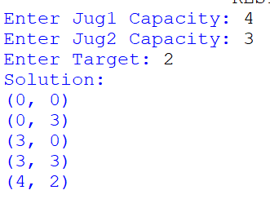

Output


Result:
Thus, the Python program to solve the Water Jug Problem using the Breadth-First Search (BFS) algorithm was executed successfully.

